**RAJALAKSHMIENGINEERING COLLEGE**

**RAJALAKSHMI NAGAR, THANDALAM – 602 105**



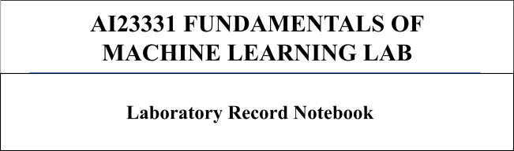

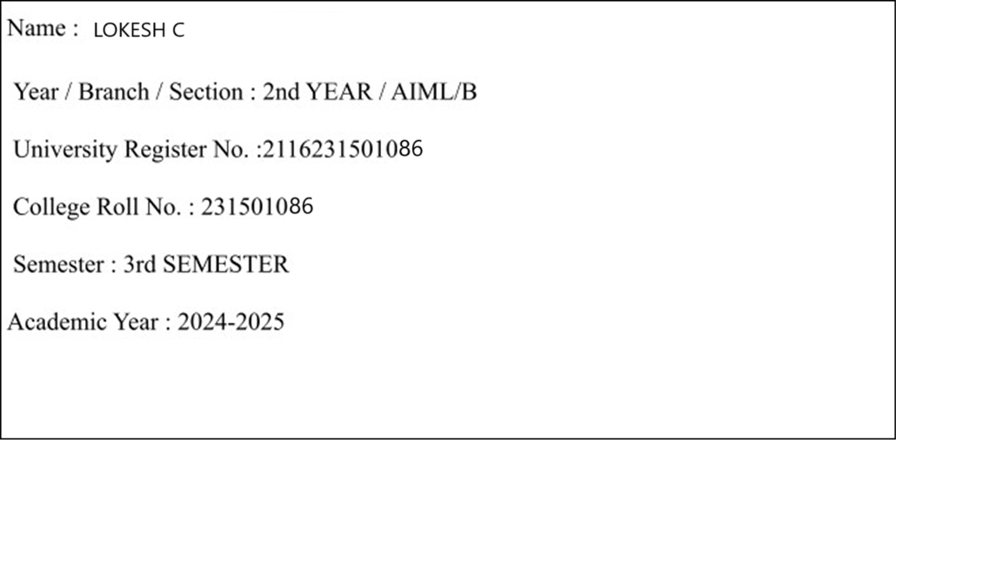

**INDEX PAGE**

|  |  |  |
| --- | --- | --- |
| SL.NO | DATE | NAME OF THE EXPERIMENT |
| 01 | 23.08.2024 | A PYTHON PROGRAM TO IMPLEMENT UNIVARIATE REGRESSION,BIVARIATE REGRESSION AND MULTIVARIATE REGRESSION. |
| 02 | 30.08.2024 | A PYTHON PROGRAM TO IMPLEMENT SIMPLE LINEAR REGRESSION USING LEAST SQUARE METHOD |
| 03 | 06.09.2024 | A PYTHON PROGRAM TO IMPLEMENT LOGISTIC MODEL |
| 04 | 13.09.2024 | A PYTHON PROGRAM TO IMPLEMENT SINGLE LAYER PERCEPTRON |
| 05 | 20.09.2024 | A PYTHON PROGRAM TO IMPLEMENT MULTI LAYER PERCEPTRON WITH BACKPROPAGATION |
| 06 | 27.09.2024 | A PYTHON PROGRAM TO DO FACE RECOGNITION USING SVM  CLASSIFIER |
| 07 | 04.10.2024 | A PYTHON PROGRAM TO IMPLEMENT DECISION TREE |
| 08 | 18.10.2024 | A PYTHON PROGRAM TO IMPLEMENT DECISION TREE |
| 09A | 25.10.2024 | A PYTHON PROGRAM TO IMPLEMENT KNN MODEL . |
| 09B | 25.10.2024 | A PYTHON PROGRAM TO IMPLEMENT K-MEANS MODEL |
| 10 | 04.11.2024 | A PYTHON PROGRAM TO IMPLEMENT DIMENSIONALITY REDUCTION -PCA. |

**EXPT NO: 1 A python program to implement univariate regression**

**DATE: 23.08.2024 bivariate regression and multivariate regression.**

**AIM:**

To write a python program to implement univariate regression, bivariate regression and multivariate regression.

**PROCEDURE:**

Implementing univariate, bivariate, and multivariate regression using the Iris dataset involve the following steps:

**Step 1: Import Necessary Libraries**

|  |
| --- |
| # Load the Iris dataset iris = sns.load_dataset('iris')    # Display the first few rows of the dataset |

print(iris.head())

First, import the libraries that are essential for data manipulation, visualization, and model building.

|  |
| --- |
| import numpy as np  import pandas as pd  import seaborn as sns |
|  |
| import matplotlib.pyplot as plt  from sklearn.model_selection import train_test_split  from sklearn.linear_model import LinearRegression  from sklearn.metrics import mean_squared_error, r2_score |

**Step 2: Load the Iris Dataset**

The Iris dataset can be loaded and display the first few rows of the dataset .

**OUTPUT :**

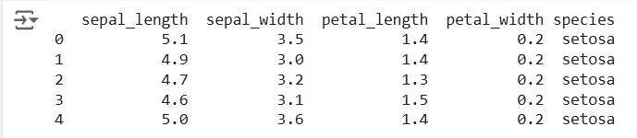

**Step 3: Data Preprocessing**

Ensure the data is clean and ready for modeling. Since the Iris dataset is clean, minimal preprocessing is needed.

|  |
| --- |
| # Check for missing values |
| print(iris.isnull().sum())    # Display the basic statistical details print(iris.describe()) |

**OUTPUT :**

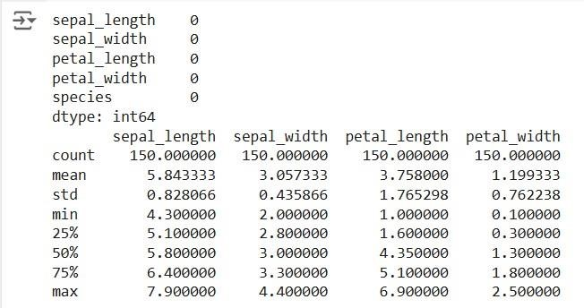

**Step 4: Univariate Regression**

Univariate regression involves predicting one variable based on a single predictor.

**4.1: Select the Features**

Choose one feature (e.g., sepal_length) and one target variable (e.g., sepal_width).

|  |
| --- |
|  |
| X_uni = iris[['sepal_length']] |
| y_uni = iris['sepal_width'] |

**4.2: Split the Data**

Split the data into training and testing sets.

Fit the linear regression model on the training data.

|  |
| --- |
| X_uni_train, X_uni_test, y_uni_train, y_uni_test = train_test_split(X_uni, |
| y_uni, |
| test_size=0.2, random_state=42) |

**4.3: Train the model**

|  |
| --- |
| uni_model = LinearRegression() |
| uni_model.fit(X_uni_train, y_uni_train) |

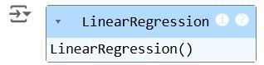

**4.4: Make Predictions**

Use the model to make predictions on the test data.

y_uni_pred = uni_model.predict(X_uni_test)

**4.5: Evaluate the Model**

Evaluate the model performance using metrics like Mean Squared Error (MSE) and R-squared.

|  |
| --- |
| print(f'Univariate MSE: {mean_squared_error(y_uni_test, y_uni_pred)}') |
| print(f'Univariate R-squared: {r2_score(y_uni_test, y_uni_pred)}') |
|  |

**OUTPUT :**



**4.6: Visualize the Results**

Visualize the relationship between the predictor and the target variable.

|  |
| --- |
| plt.scatter(X_uni_test, y_uni_test, color='blue') |
| plt.plot(X_uni_test, y_uni_pred, color='red') |
| plt.xlabel('Sepal Length') |
| plt.ylabel('Sepal Width') |
| plt.title('Univariate Regression') |
| plt.show() |

**OUTPUT :**

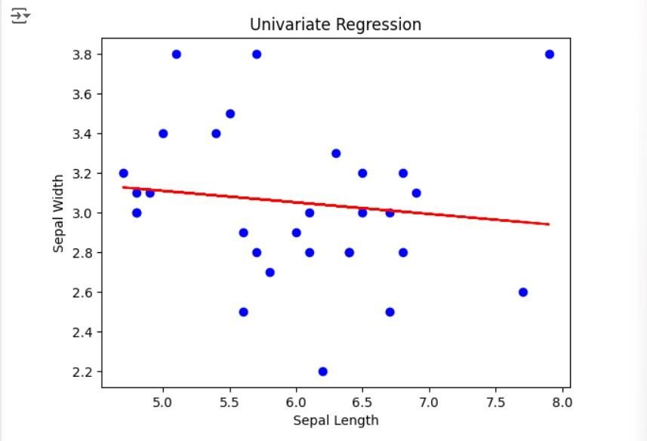

**Step 5 : Bivariate Regression**

Bivariate regression involves predicting one variable based on two predictors.

**5.1: Select the Features**

Choose two features (e.g., sepal_length, petal_length) and one target variable (e.g., sepal_width).

|  |
| --- |
| X_bi = iris[['sepal_length', 'petal_length']] |
| y_bi = iris['sepal_width'] |

**5.2: Split the Data**

Split the data into training and testing sets.

|  |
| --- |
| X_bi_train, X_bi_test, y_bi_train, y_bi_test = train_test_split(X_bi, |
| y_bi, |
| test_size=0.2, random_state=42) |

**5.3: Train the Model**

Fit the linear regression model on the training data.

|  |
| --- |
| bi_model = LinearRegression() |
|  |
| bi_model.fit(X_bi_train, y_bi_train) |

**OUTPUT :**

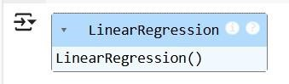

**5.4: Make Predictions**

Use the model to make predictions on the test data. y_bi_pred = bi_model.predict(X_bi_test)

**5.5: Evaluate the Model**

Evaluate the model performance using metrics like MSE and R-squared.

|  |
| --- |
| print(f'Bivariate MSE: {mean_squared_error(y_bi_test, y_bi_pred)}') |
| print(f'Bivariate R-squared: {r2_score(y_bi_test, y_bi_pred)}') |

OUTPUT :



**5.6: Visualize the Results**

Since visualizing in 3D is challenging, we can plot the relationships between the target and each predictor separately.

# Sepal Length vs Sepal Width

|  |
| --- |
| plt.subplot(1, 2, 1)  plt.scatter(X_bi_test['sepal_length'], y_bi_test, color='blue')  plt.plot(X_bi_test['sepal_length'], y_bi_pred, color='red') |
|  |
| plt.xlabel('Sepal Length')  plt.ylabel('Sepal Width') |
|  |
| # Petal Length vs Sepal Width  plt.subplot(1, 2, 2) |
|  |
| plt.scatter(X_bi_test['petal_length'], y_bi_test, color='blue')  plt.plot(X_bi_test['petal_length'], y_bi_pred, color='red')  plt.xlabel('Petal Length')  plt.ylabel('Sepal Width')  plt.suptitle('Bivariate Regression') plt.show() |

**OUTPUT :**

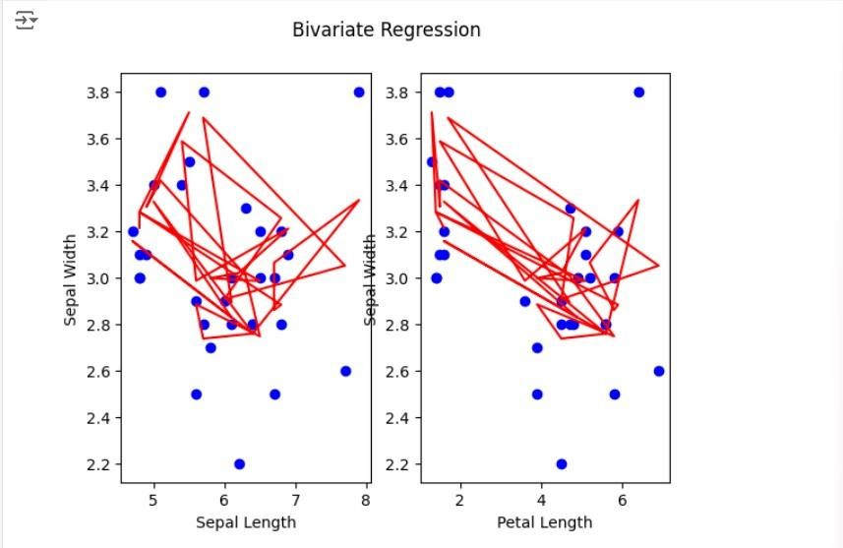

**Step 6: Multivariate Regression**

Multivariate regression involves predicting one variable based on multiple predictors.

**6.1: Select the Features**

Choose multiple features (e.g., sepal_length, petal_length, petal_width) and one target variable (e.g., sepal_width).

|  |
| --- |
| X_multi = iris[['sepal_length', 'petal_length', 'petal_width']] |
|  |
| y_multi = iris['sepal_width'] |

**6.2: Split the Data**

Split the data into training and testing sets.

|  |
| --- |
| X_multi_train, X_multi_test, y_multi_train, y_multi_test = |
| train_test_split(X_multi, |
| y_multi, test_size=0.2, random_state=42) |

**6.3: Train the Model**

Fit the linear regression model on the training data.

multi_model = LinearRegression() multi_model.fit(X_multi_train, y_multi_train)

**OUTPUT :**

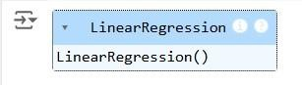

**6.4: Make Predictions**

Use the model to make predictions on the test data.

y_multi_pred = multi_model.predict(X_multi_test)

**6.5: Evaluate the Model**

Evaluate the model performance using metrics like MSE and R-squared.

|  |
| --- |
| print(f'Multivariate MSE: {mean_squared_error(y_multi_test, |
| y_multi_pred)}') |
| print(f'Multivariate R-squared: {r2_score(y_multi_test, y_multi_pred)}') |

**OUTPUT :**



**Step 7: Visualize the multivariate regression**

|  |
| --- |
| plt.figure(figsize=(15,4)) |
|  |
| plt.subplot(1, 2, 1)  plt.scatter(X_multi_test['sepal_length'], y_multi_test, color='blue')  plt.plot(X_multi_test['sepal_length'], y_multi_pred, color='red') |
|  |
| plt.xlabel('sepal_length')  plt.ylabel('sepal_width')  plt.title('Multivariate Regression-1') |
| plt.show() |
|  |
| plt.figure(figsize=(15,4))  plt.subplot(1, 2, 1) |
|  |
| plt.scatter(X_multi_test['petal_length'], y_multi_test, color='blue') |
| plt.plot(X_multi_test['petal_length'], y_multi_pred, color='red')  plt.xlabel('petal_length') |
|  |
| plt.ylabel('sepal_width') |
|  |
| plt.title('Multivariate Regression-2') plt.show() |
| plt.figure(figsize=(15,4))  plt.subplot(1, 2, 2 )  plt.scatter(X_multi_test['petal_length'], y_multi_test, color='blue') plt.plot(X_multi_test['petal_length'], y_multi_pred, color='red')  plt.xlabel('petal_length') |
| plt.ylabel('sepal_width')  plt.title('Multivariate Regression-3')  plt.show() |

**OUTPUT :**

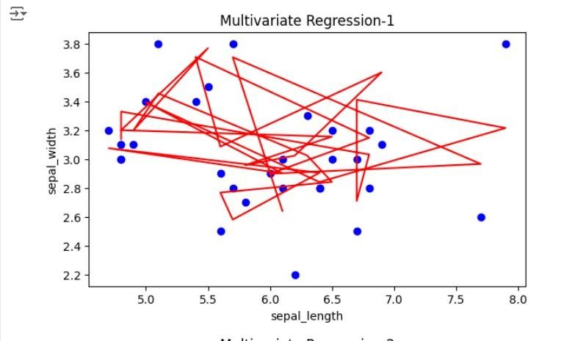

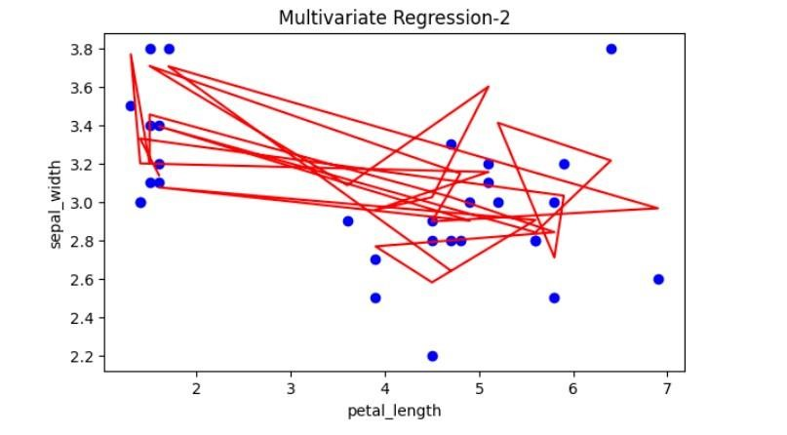

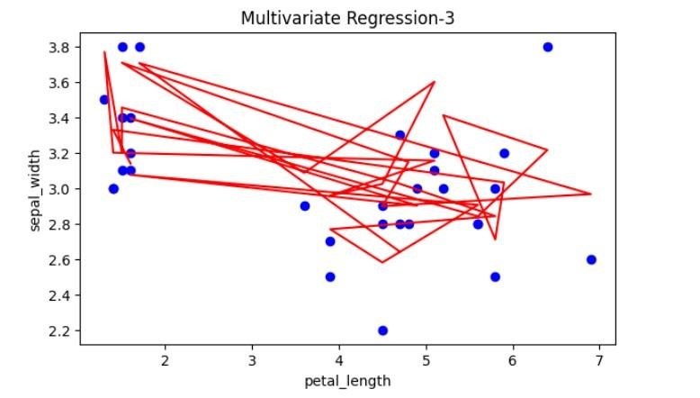

**Step 8: Interpret the Results**

After implementing and evaluating the models, interpret the coefficients to understand the influence of each predictor on the target variable.

|  |
| --- |
| print('Univariate Coefficients:', uni_model.coef_) |
| print('Bivariate Coefficients:', bi_model.coef_) |
| print('Multivariate Coefficients:', multi_model.coef_) |

**OUTPUT :**

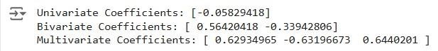

**RESULT:**

This step-by-step process will help us to implement univariate, bivariate, and multivariate regression models using the Iris dataset and analyse their performance.

**EXPT NO : 2 A python program to implement Simple linear**

**DATE: 30.08.2024 Regression using Least Square Method**

**AIM:**

To write a python program to implement Simple linear regression using Least Square Method.

**PROCEDURE:**

Implementing Simple linear regression using Least Square method using the headbrain dataset involve the following steps:

**Step 1: Import Necessary Libraries**

First, import the libraries that are essential for data manipulation, visualization, and model building.

|  |
| --- |
| import pandas as pd |
| import matplotlib.pyplot as plt |
| import numpy as np |

**Step 2: Load the Iris Dataset**

The HeadBrain dataset can be loaded. data =

pd.read_csv('/content/headbrain.csv')

**Step 3: Data Preprocessing**

Ensure the data is clean and ready for modeling. Since the Iris dataset is clean, minimal preprocessing is needed.

|  |
| --- |
| x,y=np.array(list(data['Head Size(cm^3)'])),np.array(list(data['Brain |
| Weight(grams)'])) |
| print(x[:5],y[:5]) |
|  |

**OUTPUT :**



**Step 4 :Compute the Least Squares Solution**

Apply the least squares formula to find the regression coefficients.

|  |
| --- |
| def get_line(x,y): |
| x_m,y_m = np.mean(x), np.mean(y) |
| print(x_m,y_m) |
| x_d,y_d=x-x_m,y-y_m |
| m = np.sum(x_d*y_d)/np.sum(x_d**2) |
| c = y_m - (m*x_m) |
| print(m, c) |
| return lambda x : m*x+c |
| lin=get_line(x,y) |
|  |

**OUTPUT :**



**Step 5 : Make Predictions**

Use the model to make predictions based on the independent variable.

**def get_error(line_fuc, x, y):**

|  |
| --- |
| **y_m = np.mean(y)** |
| **y_pred = np.array([line_fuc(_) for _ in x])** |
| **ss_t = np.sum((y-y_m)**2)** |
| **ss_r = np.sum((y-y_pred)**2)** |
| **return 1-(ss_r/ss_t)** |
| **get_error(lin, x, y)** |
| **from sklearn.linear_model import LinearRegression** |
| **x = x.reshape((len(x),1))** |
| **reg=LinearRegression()** |
| **reg=reg.fit(x, y)** |
| **print(reg.score(x, y))** |

**OUTPUT :**





**Step 6 :Visualize the Results**

Plot the original data points and the fitted regression line.

|  |
| --- |
| x=np.linspace(np.min(x)-100,np.max(x)+100,1000) |
| y=np.array([lin(x)for x in x]) |
| plt.plot(x, y, color='red', label='Regression line') |
| plt.scatter(x, y, color='green', label='Scatter plot') |
| plt.xlabel('Head Size(cm^3)') |
| plt.ylabel('Brain Weight(grams)') |
| plt.legend() |
| plt.show() |

**OUTPUT :**

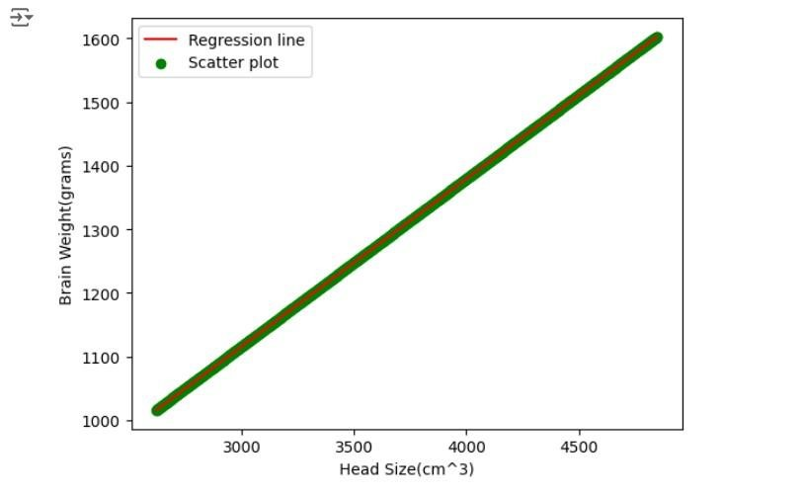

**RESULT:**

This step-by-step process will help us to implement least square regression models using the HeadBrain dataset and analyze their performance.

**EXPT NO : 3 A python program to implement Logistic Model**

**DATE: 06.09.2024**

**AIM:**

To write a python program to implement a Logistic Model.

**PROCEDURE:**

Implementing Logistic method using the iris dataset involve the following steps:

**Step 1: Import Necessary Libraries**

First, import the libraries that are essential for data manipulation, visualisation, and model building.

|  |
| --- |
| # Step 1: Import Necessary Libraries |
| import numpy as np |
| import pandas as pd |
| import matplotlib.pyplot as plt |
| from sklearn.model_selection import train_test_split |
| from sklearn.linear_model import LogisticRegression |
| from sklearn.metrics import accuracy_score, confusion_matrix, |
| classification_report |

**Step 2: Load the Iris Dataset** The iris dataset can be loaded.

|  |
| --- |
| # Step 2: Load the Dataset |
| # For this example, we'll use a built-in dataset from sklearn. You can |
| replace it with your dataset. |
| from sklearn.datasets import load_iris |
|  |
| # Load the iris dataset |
| data = load_iris() |
| X = data.data |
| y = (data.target == 0).astype(int) # For binary classification |
| (classifying Iris-setosa) |

**Step 3: Data Preprocessing**

Ensure the data is clean and ready for modeling. Since the Iris dataset is clean, minimal preprocessing is needed.

|  |
| --- |
| # Step 3: Prepare the Data |
| # Split the dataset into training and testing sets |
| X_train, X_test, y_train, y_test = train_test_split(X, y, test_size=0.2, |
| random_state=42) |

**Step 4 : Train a Model**

|  |
| --- |
| **# Step 4: Create and Train the Model** |
| **model = LogisticRegression()** |
| **model.fit(X_train, y_train)** |

**OUTPUT :**

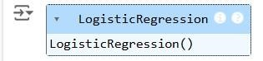

**Step 5 : Make Predictions**

Use the model to make predictions based on the independent variable.

|  |
| --- |
| # Step 5: Make Predictions |
| y_pred = model.predict(X_test) |

**Step 6 : Evaluate the Model**

Evaluate the model performance.

# Step 6: Evaluate the Model

|  |
| --- |
| accuracy = accuracy_score(y_test, y_pred) |
| conf_matrix = confusion_matrix(y_test, y_pred) |
| class_report = classification_report(y_test, y_pred) |
| # Print evaluation metrics |
| print(f"Accuracy: {accuracy}") |
| print("Confusion Matrix:") |
| print(conf_matrix) |
| print("Classification Report:") |
| print(class_report) |

**OUTPUT :**

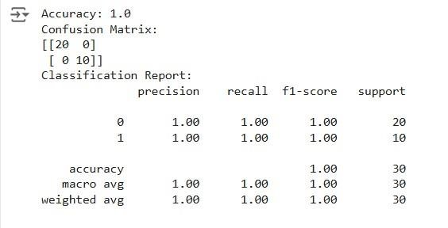

**Step 7 :Visualize the Results**

Plot the original data points and the fitted regression line.

# Step 7: Visualize Results (Optional)

|  |
| --- |
| x_values = np.linspace(-10, 10, 100) |
| sigmoid_values = 1 / (1 + np.exp(-x_values)) |
|  |
| # Plot the sigmoid function |
| plt.figure(figsize=(10, 5)) |
| plt.plot(x_values, sigmoid_values, label='Sigmoid Function', color='blue') |
| plt.title('Sigmoid Function') |
| plt.xlabel('x') |
| plt.ylabel('σ(x)') |
| plt.grid() |
| plt.axhline(0.5, color='red', linestyle='--') # Line at y=0.5 |
| plt.axvline(0, color='gray', linestyle='--') # Line at x=0 |
| plt.legend() |
| plt.show() |
|  |

**OUTPUT :**

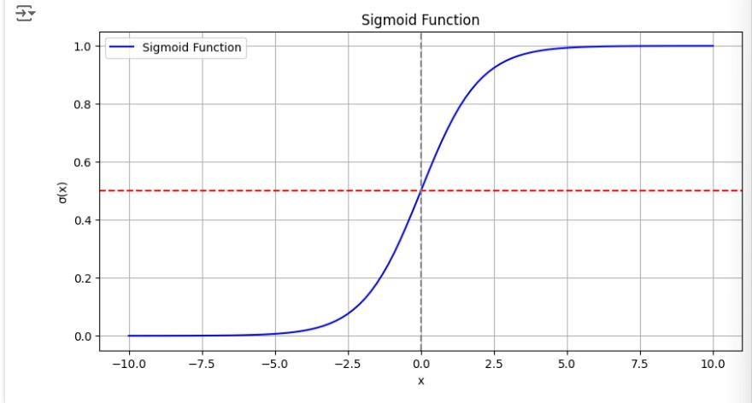

**RESULT:**

This step-by-step process will help us to implement Logistic models using the Iris dataset and analyze their performance.

**EXPT NO : 4 A python program to implement Single Layer**

**DATE: 13.09.2024 Perceptron**

**AIM:**

To write a python program to implement Single layer perceptron.

**PROCEDURE:**

Implementing Single layer perceptron method using the Keras dataset involve the following steps:

**Step 1: Import Necessary Libraries**

First, import the libraries that are essential for data manipulation, visualization, and model building.

|  |
| --- |
| import numpy as np |
| import pandas as pd |
| from tensorflow import keras |
| import matplotlib.pyplot as plt |

**Step 2: Load the Keras Dataset**

The Keras dataset can be loaded.

(X_train,y_train),(X_test,y_test)=keras.datasets.mnist.load_data()

**Step 3: Data Preprocessing**

Ensure the data is clean and ready for modeling. Since the Iris dataset is clean, minimal preprocessing is needed.

print(f"Training set:{X_train.shape}") print(f"Testing set:{X_test.shape}")

print(X_train[1].shape) plt.matshow(X_train[1])

**OUTPUT :**

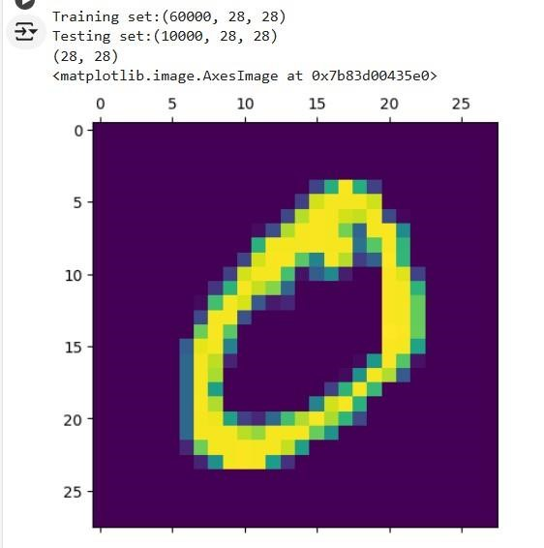

**Step 4 : Train a Model**

|  |
| --- |
| **#Normalizing the dataset** |
| **x_train=X_train/255** |
| **x_test=X_test/255** |
|  |
| **#Flatting the dataset in order to compute for model building** |
| **x_train_flatten=x_train.reshape(len(x_train),28*28)** |
| **x_test_flatten=x_test.reshape(len(x_test),28*28)** |
| **x_train_flatten.shape** |
|  |

**Step 5 : Make Predictions**

Use the model to make predictions based on the independent variable.

model=keras.Sequential([

|  |
| --- |
| keras.layers.Dense(10,input_shape=(784,), |
| activation='sigmoid') |
| ]) |
|  |
| model.compile( |
| optimizer='adam', |
| loss='sparse_categorical_crossentropy', |
| metrics=['accuracy']) |
|  |
| model.fit(x_train_flatten,y_train,epochs=5 |
|  |
| ) |

**OUTPUT :**

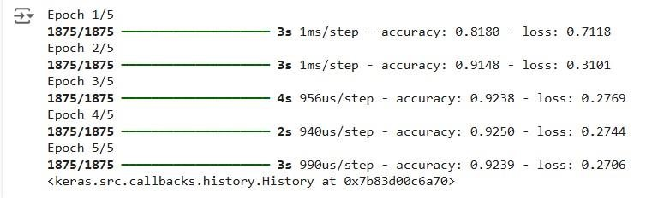

**Step 6 : Evaluate the Model**

Evaluate the model performance. model.evaluate(x_test_flatten,y_test)

**OUTPUT :**



**RESULT:**

This step-by-step process will help us to implement Single Layer Perceptron models using the Keras dataset and analyze their performance.

**EXPT NO : 5 A python program to implement Multi Layer**

**DATE: 20.09.2024 Perceptron With Backpropagation**

**AIM:**

To write a python program to implement Multilayer perceptron with backpropagation .

**PROCEDURE:**

Implementing Multilayer perceptron with backpropagation using the Keras dataset involve the following steps:

**Step 1: Import Necessary Libraries**

First, import the libraries that are essential for data manipulation, visualization, and model building.

|  |
| --- |
| # importing modules |
| import tensorflow as tf |
| import numpy as np |
| from tensorflow.keras.models import Sequential |
| from tensorflow.keras.layers import Flatten |
| from tensorflow.keras.layers import Dense |
| from tensorflow.keras.layers import Activation |
| import matplotlib.pyplot as plt |

**Step 2: Load the Keras Dataset** The Keras dataset can be loaded.

|  |
| --- |
| (x_train, y_train), (x_test, y_test) = |
| tf.keras.datasets.mnist.load_data() |

**OUTPUT :**



**Step 3: Data Preprocessing**

Ensure the data is clean and ready for modeling. Since the Iris dataset is clean, minimal preprocessing is needed.

|  |
| --- |
| # Cast the records into float values |
|  |
| x_train = x_train.astype('float32') |
|  |
| x_test = x_test.astype('float32') |
|  |
| # normalize image pixel values by dividing  # by 255  gray_scale = 255 x_train /= gray_scale  x_test /= gray_scale |
|  |
| print("Feature matrix:", x_train.shape) |
|  |
| print("Target matrix:", x_test.shape)  print("Feature matrix:", y_train.shape)  print("Target matrix:", y_test.shape) |
|  |
|  |

**OUTPUT :**

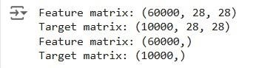

**Step 4 : Train a Model**

**model = Sequential([**

|  |
| --- |
|  |
| **# reshape 28 row * 28 column data to 28*28 rows** |
| **Flatten(input_shape=(28, 28)),** |
|  |
| **# dense layer 1** |
| **Dense(256, activation='sigmoid'),** |
|  |
| **# dense layer 2** |
| **Dense(128, activation='sigmoid'),** |
|  |
| **# output layer** |
| **Dense(10, activation='sigmoid'),** |
| **])** |
|  |

**OUTPUT:**



**Step 5 : Make Predictions**

Use the model to make predictions based on the independent variable.

model.compile(optimizer='adam',

|  |
| --- |
| loss='sparse_categorical_crossentropy', |
| metrics=['accuracy']) |
| model.fit(x_train, y_train, epochs=10, |
| batch_size=2000, |
| validation_split=0.2) |

**OUTPUT:**

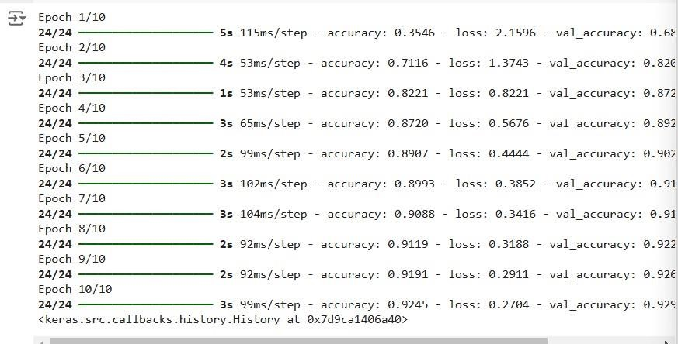

**Step 6 : Evaluate the Model**

Evaluate the model performance.

|  |
| --- |
| results = model.evaluate(x_test, y_test, verbose = 0) |
| print('test loss, test acc:', results) |
| fig, ax = plt.subplots(10, 10) |
| k = 0 |
| for i in range(10): |
| for j in range(10): |
| ax[i][j].imshow(x_train[k].reshape(28, 28), |
| aspect='auto') |
| k += 1 |
| plt.show() |

**OUTPUT :**

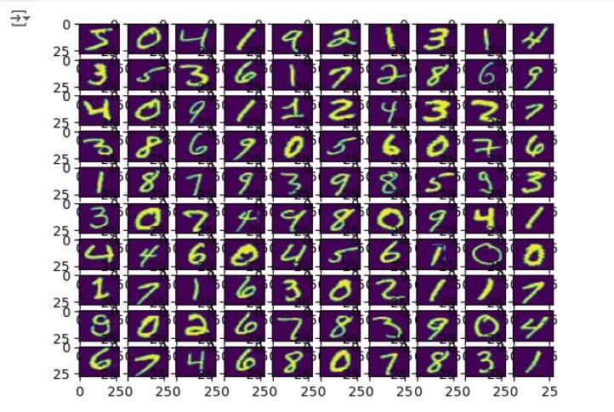

**RESULT:**

This step-by-step process will help us to implement MultiLayer Perceptron with Backpropagation models using the Keras dataset and analyze their performance. **EXPT NO: 6 A python program to do face recognition using**

**DATE: 27.09.2024 SVM Classifier**

**AIM:**

To write a python program to implement face recognition using the SVM Classifier

**PROCEDURE:**

Implementing face recognition using the SVM Classifier using the cat and dog dataset involve the following steps:

**Step 1: Import Necessary Libraries**

First, import the libraries that are essential for data manipulation, visualization, and model building.

|  |
| --- |
| import pandas as pd |
| import imageio |
| import os |
| from skimage.transform import resize |
| from skimage.io import imread |
| import numpy as np |
| import matplotlib.pyplot as plt |
| from sklearn import svm |
| from sklearn.model_selection import GridSearchCV |
| from sklearn.model_selection import train_test_split |
| from sklearn.metrics import accuracy_score |
| from sklearn.metrics import classification_report |

**Step 2: Load theDog and cat Dataset**

The dog and cat dataset can be loaded.

Categories=['cats','dogs']

|  |
| --- |
| flat_data_arr=[] #input array |
| target_arr=[] #output array |
| datadir='/content/images' |
| #path which contains all the categories of images |
| for i in Categories: |
|  |
| print(f'loading... category : {i}') |
| path=os.path.join(datadir,i) |
| for img in os.listdir(path): |
| img_array=imread(os.path.join(path,img)) |
| img_resized=resize(img_array,(150,150,3)) |
| flat_data_arr.append(img_resized.flatten()) |
| target_arr.append(Categories.index(i)) |
| print(f'loaded category:{i} successfully') |
| flat_data=np.array(flat_data_arr) |
| target=np.array(target_arr) |
| #dataframe |
| df=pd.DataFrame(flat_data) |
| df['Target']=target |
| df.shape |

**OUTPUT :**



**Step 3: Separate input features and targets.**

|  |
| --- |
| #input data |
| x=df.iloc[:,:-1] |
| #output data |
| y=df.iloc[:,-1] |

**Step 4 : Separate the input features and target**

|  |
| --- |
| **# Splitting the data into training and testing sets** |
| **x_train,x_test,y_train,y_test=train_test_split(x,y,test_size=0.20,** |
| **random_state=77, stratify=y)** |

**Step 5 : Build and train the model**

|  |
| --- |
| **# Defining the parameters grid for GridSearchCV** |
| **param_grid={'C':[0.1,1,10,100],** |
| **'gamma':[0.0001,0.001,0.1,1],** |
| **'kernel':['rbf','poly']}** |
|  |
| **# Creating a support vector classifier** |
| **svc=svm.SVC(probability=True)** |
|  |
| **# Creating a model using GridSearchCV with the parameters grid** |
| **model=GridSearchCV(svc,param_grid)** |
|  |
| **# Training the model using the training data** |
| **model.fit(x_train,y_train)** |

**OUTPUT :**

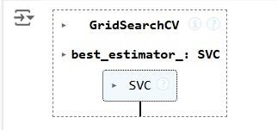

**Step 6 : Model evaluation**

|  |
| --- |
| **# Testing the model using the testing data** |
| **y_pred = model.predict(x_test)** |
|  |
| **# Calculating the accuracy of the model** |
| **accuracy = accuracy_score(y_pred, y_test)** |
|  |
| **# Print the accuracy of the model** |
| **print(f"The model is {accuracy*100}% accurate")** |
|  |
| **print(classification_report(y_test, y_pred, target_names=['cat', 'dog']))** |
|  |

**OUTPUT :**

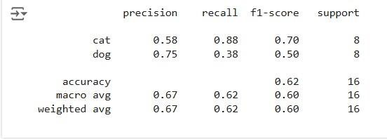

**Step 7 : Prediction**

|  |
| --- |
| **path='/content/cat.83.jpg'** |
| **img=imread(path)** |
| **plt.imshow(img)** |
| **plt.show()** |
| **img_resize=resize(img,(150,150,3))** |
| **l=[img_resize.flatten()]** |
| **probability=model.predict_proba(l)** |
| **for ind,val in enumerate(Categories):** |
| **print(f'{val} = {probability[0][ind]*100}%')** |
| **print("The predicted image is : "+Categories[model.predict(l)[0]])** |

**OUTPUT :**

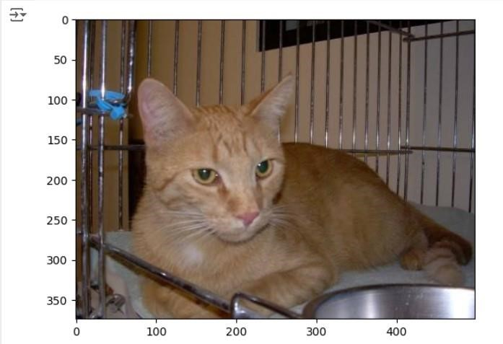

**cats = 52.70216647851706% dogs = 47.29783352148294%**

**The predicted image is :**

**cat**

**RESULT :**

Thus the process helps us to implement the face recognition using SVM Classifier using python program.

**EXPT NO: 7 A python program to implement Decision tree**

**DATE: 04.10.2024**

**AIM:**

To write a python program to implement a Decision tree.

**PROCEDURE:**

Implementing the decision tree using the Iris dataset involve the following steps:

**Step 1: Import Necessary Libraries**

First, import the libraries that are essential for data manipulation, visualization, and model building.

|  |
| --- |
| import numpy as np |
| import pandas as pd |
| from sklearn import datasets |
| from sklearn.model_selection import train_test_split |
| from sklearn.tree import DecisionTreeClassifier |
| from sklearn import metrics |
| import matplotlib.pyplot as plt |
| from sklearn.tree import plot_tree |
|  |

**Step 2: Load the Iris Dataset**

The Iris dataset can be loaded and display the first few rows of the dataset .

|  |
| --- |
| # Load the Iris dataset iris = datasets.load_iris()  X = iris.data # Features y = iris.target # Target variable |

**Step 3 : Split the data set into training and testing sets**

|  |
| --- |
| **# Split the dataset into training and testing sets** |
| **X_train, X_test, y_train, y_test = train_test_split(X, y, test_size=0.2,** |
| **random_state=42)** |

**Step 4 : Create a decision tree classifier**

|  |
| --- |
| **# Create a Decision Tree classifier** |
| **clf = DecisionTreeClassifier(random_state=42)** |

**Step 5 : Train the model :**

**# Train the model**

**clf.fit(X_train, y_train)**

**OUTPUT :**

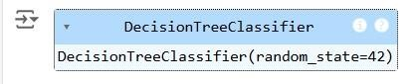

**Step 6 : Make the predictions and evaluate the model**

|  |
| --- |
| **# Make predictions** |
| **y_pred = clf.predict(X_test)** |
|  |
| **# Evaluate the model** |
| **accuracy = metrics.accuracy_score(y_test, y_pred)** |
| **confusion = metrics.confusion_matrix(y_test, y_pred)** |
| **classification_report = metrics.classification_report(y_test, y_pred)** |
|  |
| **print(f"Accuracy: {accuracy:.2f}")** |
| **print("Confusion Matrix:")** |
| **print(confusion)** |
| **print("Classification Report:")** |
| **print(classification_report)** |

**OUTPUT :**

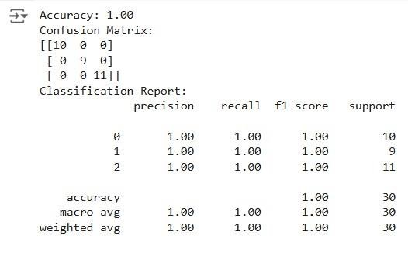

**Step 7 : Visualize the decision tree**

|  |
| --- |
| **# Visualize the Decision Tree** |
| **plt.figure(figsize=(12,8))** |
| **plot_tree(clf, filled=True, feature_names=iris.feature_names,** |
| **class_names=iris.target_names)** |
| **plt.title("Decision Tree Visualization")** |
| **plt.show()** |
|  |

**OUTPUT :**

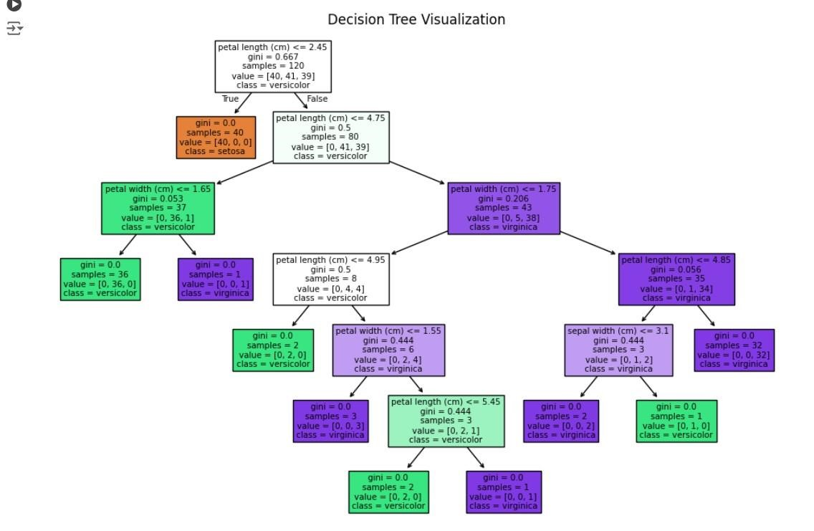

**RESULT :**

**This process helps us to implement the decision tree using a python program.**

**EX.NO: 8 A PYTHON PROGRAM TO IMPLEMENT**

**DATE : 18.10.2024 ADA BOOSTING**

**AIM:**

To write a python program to implement ADA Boosting.

**PROCEDURE:**

Implementing ADA Boosting using the dataset involve the following steps:

**Step 1: Import Necessary Libraries**

First, import the libraries that are essential for data manipulation, visualization, and model building.

|  |
| --- |
| import numpy as np |
| import pandas as pd |
| from sklearn.tree import DecisionTreeClassifier |
| from mlxtend.plotting import plot_decision_regions |
| import seaborn as sns |
| from sklearn.metrics import accuracy_score |

**Step 2 : Load and prepare data**

|  |
| --- |
| **df = pd.DataFrame()** |
| **df['X1'] = [1, 2, 3, 4, 5, 6, 6, 7, 9, 9]** |
| **df['X2'] = [5, 3, 6, 8, 1, 9, 5, 8, 9, 2]** |
| **df['label'] = [1, 1, 0, 1, 0, 1, 0, 1, 0, 0]** |
| **sns.scatterplot(x=df['X1'], y=df['X2'], hue=df['label'])** |
|  |
| **df['weights'] = 1 / df.shape[0]** |
| **x = df.iloc[:, 0:2].values** |
| **y = df.iloc[:, 2].values** |

**OUTPUT :**

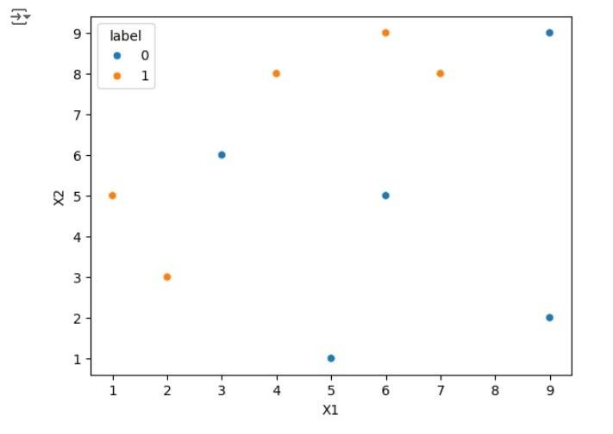

**Step 3 : Train the 1st model**

|  |
| --- |
| **# Step 2: Train 1st Model** |
| **dt1 = DecisionTreeClassifier(max_depth=1)** |
| **dt1.fit(x, y)** |
| **plot_decision_regions(x, y, clf=dt1, legend=2)** |
| **df['y_pred'] = dt1.predict(x)** |
|  |

**OUTPUT :**

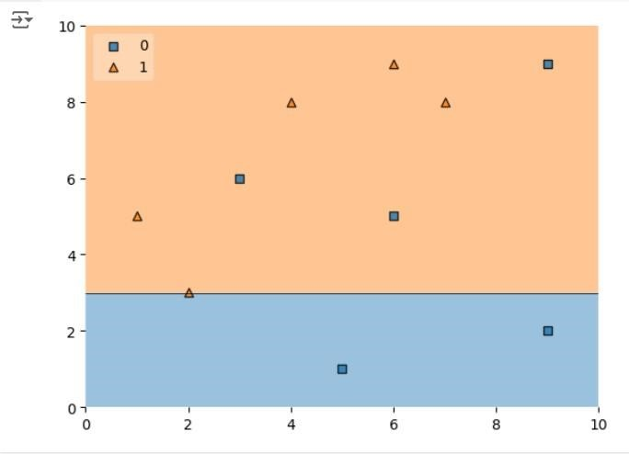

**Step 4 : Calculate model weight**

|  |
| --- |
| **# Step 4: Update Weights** |
| **def update_row_weights(row, alpha=0.423):** |
| **if row['label'] == row['y_pred']:** |
| **return row['weights'] * np.exp(-alpha)** |
| **else:** |
| **return row['weights'] * np.exp(alpha)** |
|  |
| **df['updated_weights'] = df.apply(update_row_weights, axis=1)** |
| **df['normalized_weights'] = df['updated_weights'] /** |
| **df['updated_weights'].sum()** |
| **df['cumsum_upper'] = np.cumsum(df['normalized_weights'])** |
| **df['cumsum_lower'] = df['cumsum_upper'] - df['normalized_weights']** |

**Step 5 : Create new dataset**

**# Step 5: Create New Dataset**

|  |
| --- |
| **def create_new_dataset(df):** |
| **indices = []** |
| **for i in range(df.shape[0]):** |
| **a = np.random.random()** |
| **for index, row in df.iterrows():** |
| **if row['cumsum_upper'] > a and a > row['cumsum_lower']:** |
| **indices.append(index)** |
| **return indices** |
|  |
| **index_values = create_new_dataset(df)** |
| **second_df = df.iloc[index_values, [0, 1, 2, 3]]** |

**Step 6 : Train 2nd model**

|  |
| --- |
| **# Step 6: Train 2nd Model** |
| **dt2 = DecisionTreeClassifier(max_depth=1)** |
| **x = second_df.iloc[:, 0:2].values** |
| **y = second_df.iloc[:, 2].values** |
| **dt2.fit(x, y)** |

**OUTPUT :**

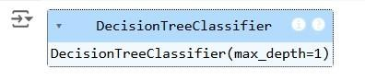

**Step 7 : Plot decision tree and calculate model weights for 2nd model**

|  |
| --- |
| **# Plot the decision tree for the second model** |
| **plot_decision_regions(x, y, clf=dt2, legend=2)** |
| **second_df['y_pred'] = dt2.predict(x)** |
|  |
| **# Step 7: Calculate Model Weight for 2nd Model** |
| **alpha2 = calculate_model_weight(0.1)** |
| **print(f"Alpha2: {alpha2}")** |

**Step 8 : update weights for 2nd model**

|  |
| --- |
| **# Step 8: Update Weights for 2nd Model** |
| **def update_row_weights(row, alpha=1.09):** |
| **if row['label'] == row['y_pred']:** |
| **return row['weights'] * np.exp(-alpha)** |
| **else:** |
| **return row['weights'] * np.exp(alpha)** |
|  |
| **second_df['updated_weights'] = second_df.apply(update_row_weights, axis=1)** |
| **second_df['nomalized_weights'] = second_df['updated_weights'] /** |
| **second_df['updated_weights'].sum()** |
| **second_df['cumsum_upper'] = np.cumsum(second_df['nomalized_weights'])** |
| **second_df['cumsum_lower'] = second_df['cumsum_upper'] -** |
| **second_df['nomalized_weights']** |

**Step 9 : Calculate alpha for 3rd model**

|  |
| --- |
| **# Step 9: Calculate Alpha for 3rd Model** |
| **alpha3 = calculate_model_weight(0.7)** |
| **print(f"Alpha3: {alpha3}")** |
|  |
| **# Step 10: Accuracy Calculation** |
| **y_true = second_df['label'].values** |
| **y_pred = second_df['y_pred'].values** |
|  |
| **# Calculate accuracy for the AdaBoost model** |
| **accuracy = accuracy_score(y_true, y_pred)** |
| **print(f"Accuracy of the AdaBoost model: {accuracy:.4f}")** |

**OUTPUT :**

**ALPHA 3: -0.4236489301936017**

**Accuracy of the Ada Boosting model : 0.80000** **RESULT :**

Thus the python program to implement Adaboosting has been executed successfully and the results have been verified.

**EXPT NO: 9A A python program to implement** **DATE: 25.10.2024 KNN MODEL .**

**AIM:**

To write a python program to implement KNN Model.

**PROCEDURE:**

Implementing KNN Model using the mall_customer dataset involve the following steps:

**Step 1: Import Necessary Libraries**

First, import the libraries that are essential for data manipulation, visualization, and model building.

|  |
| --- |
| **import numpy as np** |
| **import matplotlib.pyplot as plt** |
| **import pandas as pd** |
| **from sklearn.model_selection import train_test_split** |
| **from sklearn.preprocessing import StandardScaler** |
| **from sklearn.neighbors import KNeighborsClassifier** |
| **from sklearn.metrics import classification_report, confusion_matrix** |
| **from sklearn.cluster import KMeans** |

**Step 2: Load the Dataset**

The mall_customer dataset can be loaded and display the first few rows of the dataset.

|  |
| --- |
| **# Load the dataset** |
| **dataset = pd.read_csv('/content/Mall_Customers.csv')** |
|  |
| **# Display the first few rows of the dataset** |
| **print(dataset.head())** |
|  |
| **# Display the dimensions of the dataset** |
| **print(f"Dataset shape: {dataset.shape}")** |
|  |
| **# Display descriptive statistics of the dataset** |
| **print(dataset.describe())** |

**Step 3 : Separate the features (x) and target variable (y)**

|  |
| --- |
| **# Separate the features (X) and the target variable (y)** |
| **X = dataset.iloc[:, [3, 4]].values # We use 'Annual Income' and 'Spending** |
| **Score'** |
|  |
| **# Standardize the features** |
| **scaler = StandardScaler()** |
| **X_scaled = scaler.fit_transform(X)** |
|  |

**Step 4 : Visualizing the cluster of customer**

|  |
| --- |
| **# Apply KMeans clustering using the Elbow Method to find the optimal** |
| **number of clusters** |
| **wcss = [] # Within-cluster sum of squares** |
| **for i in range(1, 11):** |
| **kmeans = KMeans(n_clusters=i, init='k-means++', max_iter=300,** |
| **n_init=10, random_state=0)** |
| **kmeans.fit(X_scaled)** |
| **wcss.append(kmeans.inertia_)** |
|  |
| **# Plot the Elbow Method graph** |
| **plt.plot(range(1, 11), wcss)** |
| **plt.title('The Elbow Method')** |

|  |
| --- |
| **plt.xlabel('Number of clusters')** |
| **plt.ylabel('WCSS')** |
| **plt.show()** |
|  |
| **# From the plot, we can observe that the optimal number of clusters is 5** |
| **(elbow point)** |
| **kmeans = KMeans(n_clusters=5, init='k-means++', max_iter=300, n_init=10,** |
| **random_state=0)** |
| **y_kmeans = kmeans.fit_predict(X_scaled)** |
|  |
| **# Visualizing the clusters of customers** |
| **plt.scatter(X_scaled[y_kmeans == 0, 0], X_scaled[y_kmeans == 0, 1], s=100,** |
| **c='red', label='Cluster 1')** |
| **plt.scatter(X_scaled[y_kmeans == 1, 0], X_scaled[y_kmeans == 1, 1], s=100,** |
| **c='blue', label='Cluster 2')** |
| **plt.scatter(X_scaled[y_kmeans == 2, 0], X_scaled[y_kmeans == 2, 1], s=100,** |
| **c='green', label='Cluster 3')** |
| **plt.scatter(X_scaled[y_kmeans == 3, 0], X_scaled[y_kmeans == 3, 1], s=100,** |
| **c='cyan', label='Cluster 4')** |
| **plt.scatter(X_scaled[y_kmeans == 4, 0], X_scaled[y_kmeans == 4, 1], s=100,** |
| **c='magenta', label='Cluster 5')** |
|  |
| **# Plot the centroids** |
| **plt.scatter(kmeans.cluster_centers_[:, 0], kmeans.cluster_centers_[:, 1],** |
| **s=300, c='yellow', label='Centroids')** |
|  |
| **plt.title('Clusters of customers')** |
| **plt.xlabel('Annual Income (k$)')** |
| **plt.ylabel('Spending Score (1-100)')** |
| **plt.legend()** |
| **plt.show()** |

**OUTPUT :**

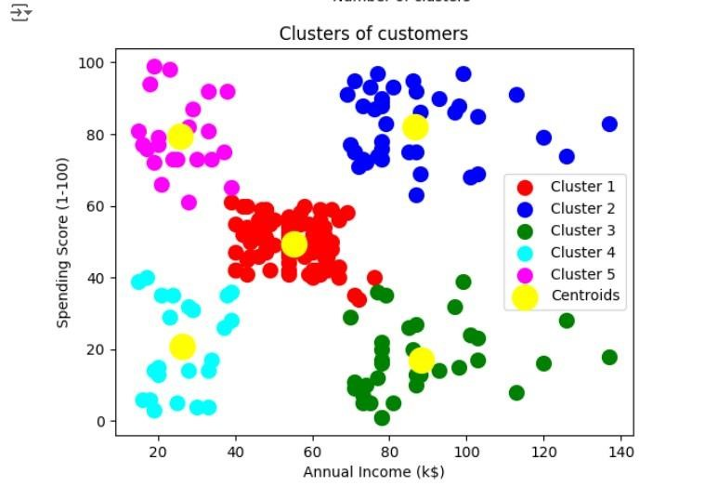

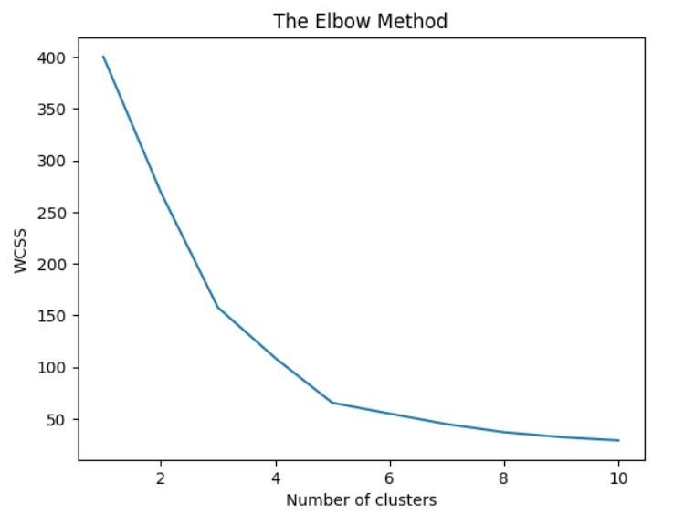

**RESULT :**

Thus the python program to implement KNN model has been successfully implemented and the results have been verified.

**EXPT NO: 9B** **A python program to implement**

**DATE: 25.10.2024** **K-Means Model**

**AIM:**

To write a python program to implement the K-means Model.

**PROCEDURE:**

Implementing K - means Model using the mall_customer dataset involve the following steps:

**Step 1: Import Necessary Libraries**

First, import the libraries that are essential for data manipulation, visualization, and model building.

|  |
| --- |
| import numpy as np |
| import pandas as pd |
| from math import sqrt |

**Step 2 : load the Dataset**

|  |
| --- |
| **data = pd.read_csv('/content/Mall_Customers.csv')** |
| **data.head(5)** |

**OUTPUT:**

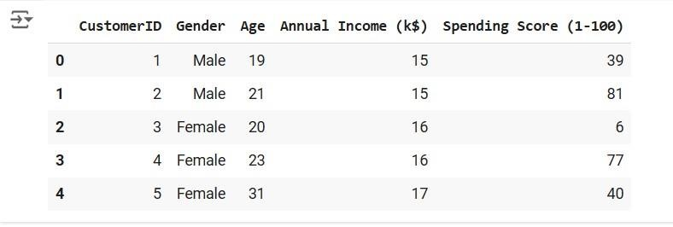

**Step 3 : Preprocess the data**

|  |
| --- |
| **req_data = data[['Age', 'Annual Income (k$)', 'Spending Score (1-100)']]** |
|  |
| **req_data.head(5)** |

**OUTPUT :**

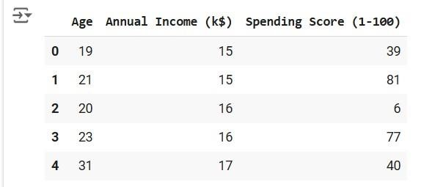

**Step 4 : Assign the data points to clusters**

|  |
| --- |
| **shuffle_index = np.random.permutation(req_data.shape[0])** **# Shuffle the** |
| **dataset rows** |
| **req_data = req_data.iloc[shuffle_index]** |
| **req_data.head(5)** |

**OUTPUT :**

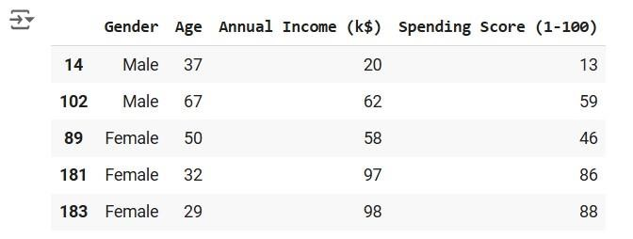

**Step 5 : Update the clusters centers**

|  |
| --- |
| **train_size = int(req_data.shape[0]*0.7)** **# Set 70% of the data for** |
| **training** |

|  |
| --- |
| **train_df = req_data.iloc[:train_size,:]** |
| **test_df = req_data.iloc[train_size:,:]** |

|  |
| --- |
| **train = train_df.values # Convert train data to numpy array** |
| **test = test_df.values # Convert test data to numpy array** |
| **y_true = test[:,-1] # The target values for the test set** |
| **print('Train_Shape: ', train_df.shape)** |
| **print('Test_Shape: ', test_df.shape)** |
| **from math import sqrt** |
|  |
| **def euclidean_distance(x_test, x_train):** |
| **distance = 0** |
| **for i in range(len(x_test)): # Loop through all features** |
| **distance += (x_test[i]-x_train[i])**2** |
| **return sqrt(distance)** |
|  |
| **def get_neighbors(x_test, x_train, num_neighbors):** |
| **distances = []** |
| **data = []** |
| **for i in x_train:** |
| **distances.append(euclidean_distance(x_test, i))** |
| **data.append(i)** |
| **distances = np.array(distances)** |
| **data = np.array(data)** |
| **sort_indexes = distances.argsort() # Sort distances in ascending** |
| **order** |
| **data = data[sort_indexes] # Sort the data based on sorted distances** |

|  |
| --- |
| **return data[:num_neighbors] # Return the closest 'num_neighbors'** |
| **neighbors** |
| **def prediction(x_test, x_train, num_neighbors):** |
| **classes = []** |
| **neighbors = get_neighbors(x_test, x_train, num_neighbors)** |
| **for i in neighbors:** |
| **classes.append(i[-1]) # The target value is the last column** |
| **predicted = max(classes, key=classes.count) # Return the most** |
| **frequent class (the majority vote)** |
| **return predicted** |
|  |
| **def predict_classifier(x_test):** |
| **classes = []** |
| **neighbors = get_neighbors(x_test, req_data.values, 5) # Predict using** |
| **the top 5 neighbors** |
| **for i in neighbors:** |
| **classes.append(i[-1])** |
| **predicted = max(classes, key=classes.count) # Return the majority** |
| **vote** |

|  |
| --- |
| **print(predicted)** |
| **return predicted** |
| **def accuracy(y_true, y_pred):** |
| **num_correct = 0** |
| **for i in range(len(y_true)):** |
| **if y_true[i] == y_pred[i]: # Compare true values to predicted** |
| **values** |
| **num_correct += 1** |
| **accuracy = num_correct / len(y_true) # Calculate accuracy as the** |
| **ratio of correct predictions** |
| **return accuracy** |
| **def accuracy(y_true, y_pred):** |
| **num_correct = 0** |
| **for i in range(len(y_true)):** |
| **if y_true[i] == y_pred[i]:** |
| **num_correct += 1** |
| **return num_correct / len(y_true)** |
| **y_pred = []** |
| **for i in test:** |
| **y_pred.append(prediction(i, train,** **5))** **# Make predictions for each** |
| **test instance** |
|  |
| **# Calculate and print the accuracy** |
| **acc = accuracy(y_true, y_pred)** |
| **print(f"Accuracy: {acc * 1000:.2f}%")** |

**OUTPUT :**



**RESULT :**

Thus the python program implementing the k-means model is successful. **EXPT NO: 10 A python program to implement Dimensionality**

**DATE: 04.11.2024 Reduction -PCA.**

**AIM:**

To write a python program to implement Dimensionality Reduction - PCA .

**PROCEDURE:**

ImplementingDimensionality reduction -pca using the Iris dataset involve the following steps:

**Step 1: Import Necessary Libraries**

First, import the libraries that are essential for data manipulation, visualization, and model building.

**# Importing necessary libraries**

|  |
| --- |
| **from sklearn import datasets** |
| **import pandas as pd** |
| **from sklearn.preprocessing import StandardScaler** |
| **from sklearn.decomposition import PCA** |
| **import seaborn as sns** |
| **import matplotlib.pyplot as plt** |

**Step 2: Load the Iris Dataset**

The Iris dataset can be loaded and display the first few rows of the dataset

|  |
| --- |
| # Load the Iris dataset |
| iris = datasets.load_iris() |
| df = pd.DataFrame(iris['data'], columns=iris['feature_names']) |
|  |
| # Display the first few rows of the dataset |
| df.head() |

**OUTPUT :**

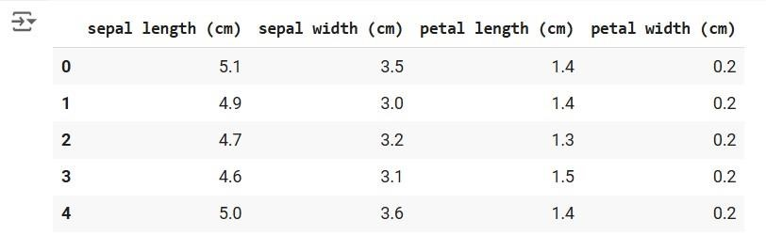

**Step 3 : Standardize the data**

**# Standardize the features using StandardScaler**

|  |
| --- |
| **scalar = StandardScaler()** |
| **scaled_data = pd.DataFrame(scalar.fit_transform(df))** **# Scaling the data** |
|  |
| **# Display the scaled data (optional)** |
| **scaled_data.head()** |

**OUTPUT :**

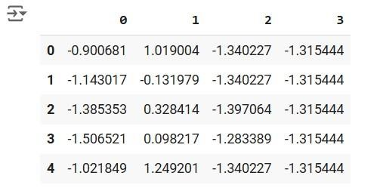

**Step 4 : Apply PCA**

|  |
| --- |
| **# Apply PCA to reduce the data to 3 components** |
| **pca = PCA(n_components=3)** |
| **pca.fit(scaled_data) # Fit PCA on scaled data** |
| **data_pca = pca.transform(scaled_data) # Transform the data to principal** |
| **components** |
|  |
| **# Convert PCA data to a DataFrame for easier inspection** |
| **data_pca = pd.DataFrame(data_pca, columns=['PC1', 'PC2', 'PC3'])** |
| **data_pca.head()** |

**OUTPUT :**

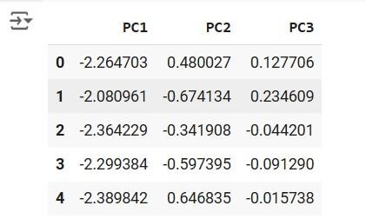

**Step 5 : Explained Variance Ratio**

|  |
| --- |
| **# Calculate the explained variance ratio for each principal component** |
| **explained_variance = pca.explained_variance_ratio_** |
| **print(f"Explained Variance Ratio: {explained_variance}")** |
|  |
| **# This output shows how much variance each principal component explains.** |

**OUTPUT :**



**Step 6 :Visualize the reduced data.**

|  |
| --- |
| **# Plotting the explained variance ratio as a scree plot** |
| **plt.figure(figsize=(8, 5))** |
| **plt.bar(range(1, len(explained_variance) + 1), explained_variance,** |
| **alpha=0.7, color='blue')** |
| **plt.ylabel('Explained Variance Ratio')** |
| **plt.xlabel('Principal Components')** |
| **plt.title('Scree Plot')** |

**plt.show()**

**OUTPUT :**

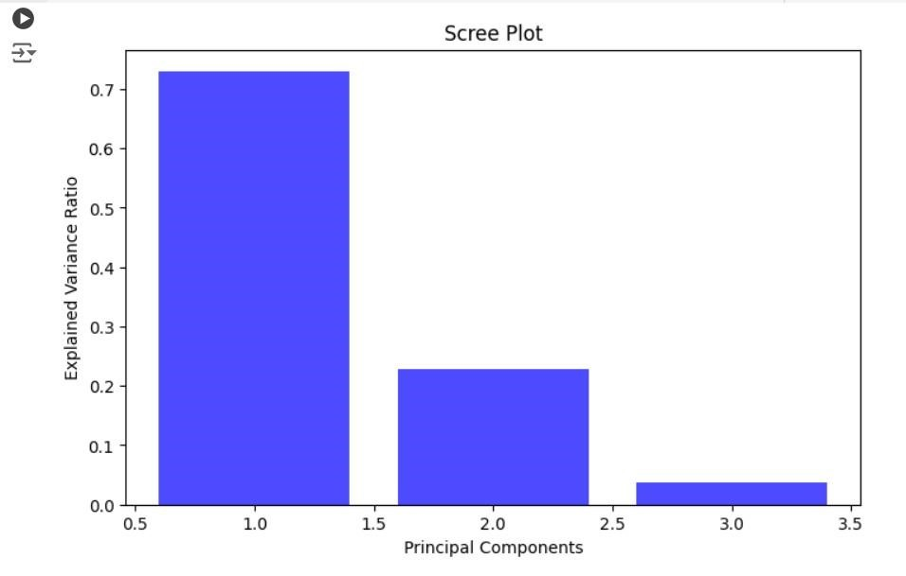

**RESULT :**

Thus the Dimensionality Reduction has been implemented using PCA in python program Successfully.